

Document Title in Title Case
Subtitle in sentence case: what this document is and who it is for
Month Year

Section Heading on a Yellow Bar
This page shows the styles in the Styles pane. Apply them by name instead of formatting text by hand; the document stays consistent when every page uses the same names.

Heading 1 Is PBS Blue
Body text is Arial 12 pt on 1.5 line spacing, black, left-aligned and never justified. Twelve point is the floor for body copy in print. Title Case for the title and Heading 1; sentence case for everything below.

Heading 2 is Navy, sentence case
Emphasize a phrase with the Marker character style: bold Navy on the Yellow block, the document’s one accent.
- Bulleted lists use a plain round bullet in PBS Blue.
- Keep each item to one or two lines.
- Numbered lists use plain numerals.
- No decorative icons, drop shadows, text effects or clip art.

Heading 3 is a minor heading at 12 pt
Use it for run-in or minor headings inside a section.
Callout. A callout box holds a definition, a note or the key sentence of a section. It sits on Cloud with a PBS Blue rule at the left and keeps the body size.
“A pull quote sits in italic on the Yellow banner, with the name in bold below.”
Name Surname, Title

Tables and Figures
Tables take the Nashville PBS Table style from the Table Design tab: a Navy header row, Fog zebra rows, hairline rules and no vertical rules. Cells are 10 pt; numbers align right.
Measure | Baseline | Target | Change
Measure A (for example, weekly reach) | [baseline] | [target] | [change]
Measure B | [baseline] | [target] | [change]
Measure C | [baseline] | [target] | [change]
Measure D | [baseline] | [target] | [change]
Table 1. Placeholder measures. Source: name the source and period.
1.1 Strategy Name
Numbered strategies and callout labels are bold Navy on a small Yellow block (the Strategy Label style), followed by one paragraph.
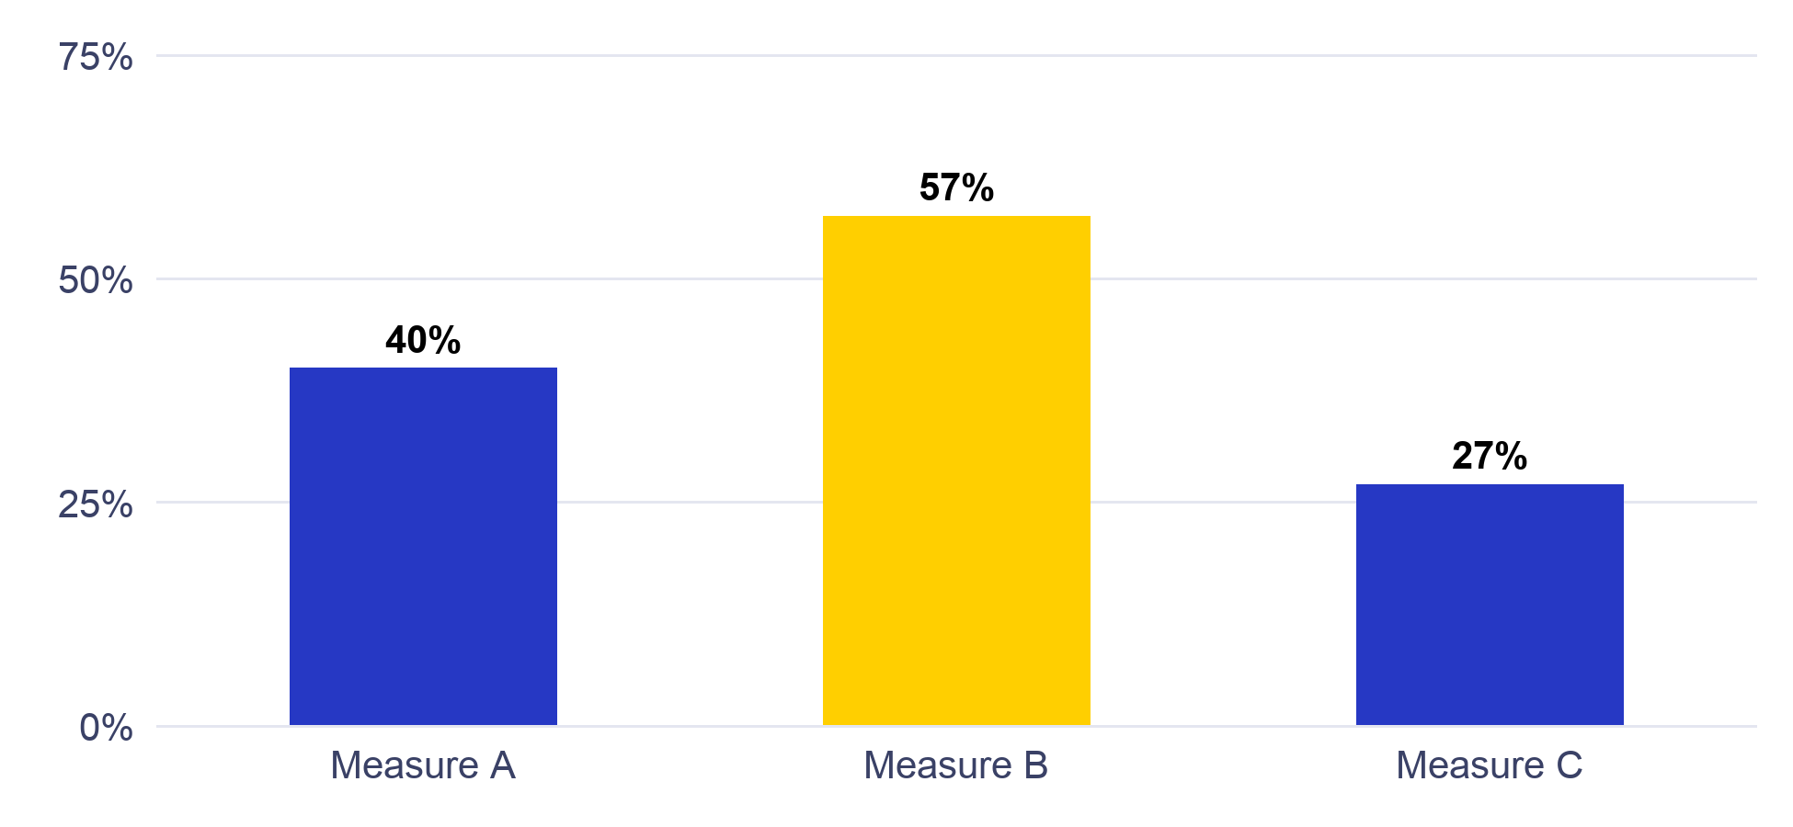
Figure 1. One series in PBS Blue, the measure the page is about in Yellow; labels 10 pt or larger. Source: sample data.
Section 02

Section Divider
Dividers are solid Navy or Medium Blue with white type and the white logo, with one circular photo crop bleeding off the edge or none at all. Body pages are white.

Using This Template
The styles carry the system. Apply them from the Styles pane (Home tab) rather than formatting by hand:
- Title 28 pt; Heading 1 20 pt PBS Blue; Heading 2 15 pt Navy; Heading 3 12 pt Navy.
- Normal body 12 pt on 1.5 line spacing; Caption 10 pt italic; Small and Table Text 10 pt.
- Section Bar for a major section heading; Strategy Label for numbered strategies; Marker for one emphasized phrase.
- Callout for a boxed note; Pull Quote and Pull Quote Name for a quote on the Yellow banner.
- Cover Label, Cover Title, Cover Subtitle and Cover Text for type on a Navy page; List Bullet and List Number for lists.

Pages and furniture
US Letter with 0.75 in margins. The header carries the small color logo and the document title: set the title under File, Properties, Summary, then update fields, or double-click the header and type over it. The footer carries Nashville PBS and the page number over a hairline rule. Covers and dividers have no header or footer; to add a divider, copy the divider page.
One accent per document. This template uses Yellow for the section bar, labels, marker and pull quote; Teal or Coral may take its place across a whole document, never mixed within one. Tables use the Nashville PBS Table style (Table Design tab).
Arial stands in for PBS Sans, which is not installed on most staff computers; do not substitute another typeface. The website is wnpt.org. Full rules: the Nashville PBS Design System, Documents section.

